

Картинка | Размеры | Цена в кожзаме | Цена в ткани
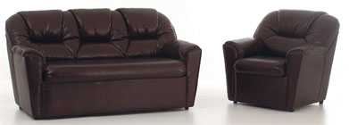 | 880*930*880 | 9691 | 11012
 | 1550*930*880 | 17050 | 19375
 | 1750*930*880 | 19250 | 21875
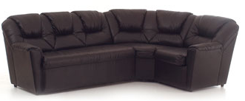 | 1950*1950*880 | 21450 | 24375
 | 2550*1950*880 | 28050 | 31875
 | 2800*1950*880 | 30800 | 35000
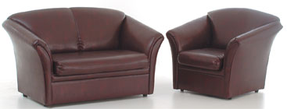 | 1030*850*900 | 10300 | 11330
 | 1520*850*900 | 15200 | 16720
 | 2030*850*900 | 20300 | 22330
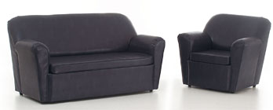 | 880*930*880 | 8800 | 9680
 | 1550*930*880 | 15500 | 17050
 | 1800*930*880 | 18000 | 19800
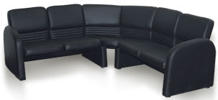 | 2130*650*760 | 17040 | 19170
 | 1320*1820*760 | 10560 | 11880
 | 650*650*760
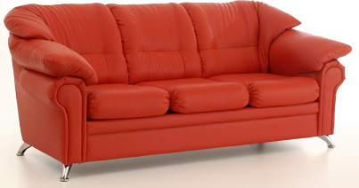 | 1000*920*850 | 12500 | 14000
 | 1660*920*850 | 20750 | 23240
 | 2120*920*850 | 26500 | 29680
 | 1790*1790*850
 | 2340*1790*850
 | 2890*1790*850
 | 425*425
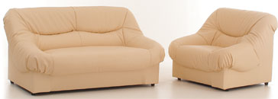 | 980*920*850 | 11760 | 13230
 | 1560*920*850 | 18720 | 21060
 | 1850*920*850 | 22200 | 24975
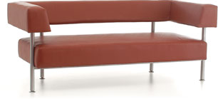 | 840*830*790 | 5460 | 6300
 | 1510*830*790 | 9815 | 11325
 | 1910*830*790 | 12415 | 14325
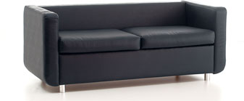 | 800*730*680 | 6400 | 7200
 | 1750*730*680 | 14000 | 15750
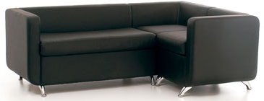 | 2020*1420*710 | 18180 | 20200
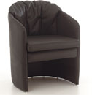 | 640*620*760 | 4480 | 5120
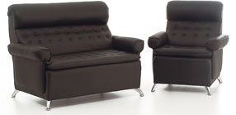 | 900*980*1000 | 9000 | 9900
 | 1440*980*1000 | 14400 | 15840
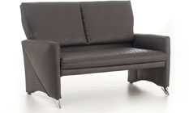 | 1480*860*940 | 11840 | 13320
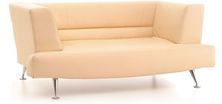 | 1740*860*710 | 13050 | 147907
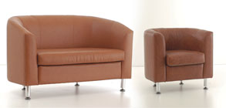 | 800*700*750 | 4800 | 5600
 | 1430*700*850 | 8580 | 10010
 | 1800*700*850 | 10800 | 12600
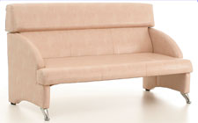 | 1650*800*910 | 11550 | 13200
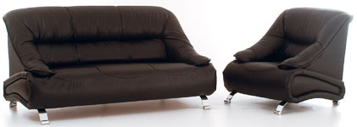 | 970*1020*1030 | 11155 | 12610
 | 1640*1020*1030 | 18860 | 21320
 | 2000*1020*1030 | 23000 | 26000
 | 1360*740*1000
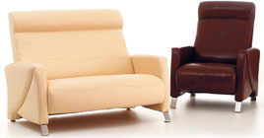 | 840*980*1120 | 7140 | 7980
 | 1440*980*1060 | 12240 | 13680
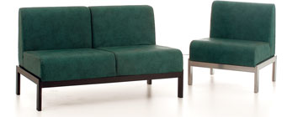 | 680*660*770 | 5780 | 6460
 | 1310*660*770 | 11135 | 12445
 | 1940*660*770 | 16490 | 18430
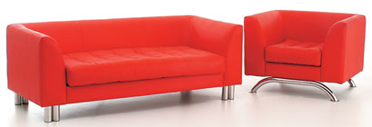 | 970*830*680 | 8245 | 9215
 | 1610*830*680 | 13685 | 15295
 | 1910*830*680 | 16235 | 18145
 | 2225*1750*680
 | 1110*830*700 | 10545 | 11655
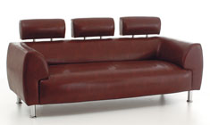 | 1110*830*910 | 10545 | 11655
 | 1610*830*680 | 15295 | 16905
 | 1610*830*910
 | 2110*830*680 | 20045 | 22155
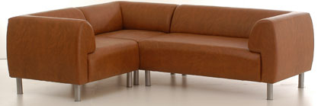 | 2110*830*910 | 18990 | 21100
 | 1780*2270*680 | 16020 | 17800
 | 2000*940*800 | 23000 | 26000
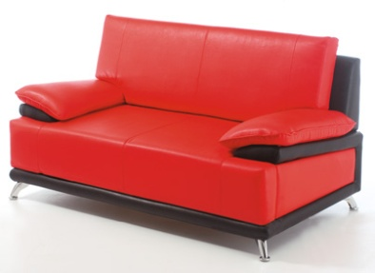 | 1160*900*900 | 11600 | 13340
 | 1660*900*900 | 16600 | 19090
 | 2060*900*900 | 20600 | 23690
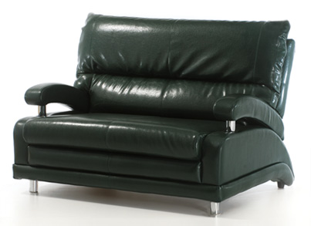 | 850*930*980 | 9350 | 10625
 | 1350*930*980 | 14850 | 16875
 | 1850*930*980 | 20350 | 23125
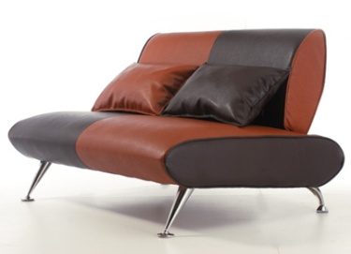 | 620*970*780 | 5580 | 6200
 | 1240*970*780 | 11160 | 12400
 | 1600*970*780 | 14400 | 16000
 | 600*600*400
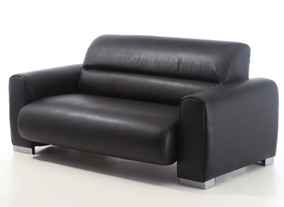 | 1000*950*810 | 10000 | 11000
 | 1750*950*810 | 17500 | 19250
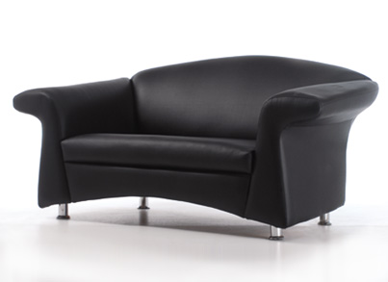 | 1350*930*890 | 13500 | 14850
 | 1880*930*890 | 18800 | 20680
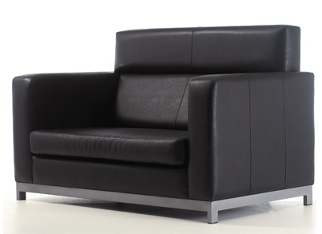 | 1440*860*940 | 12960 | 14400
 | 1940*860*940 | 17460 | 19400
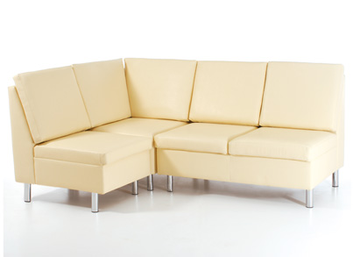 | 610*850*970 | 3965 | 4575
 | 1210*850*970 | 7865 | 9075
 | 1830*850*970 | 11895 | 13725
 | 840*850*970 | 5460 | 6300
 | 600*600*460
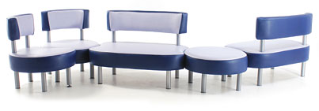 | 710*710*450 | 3615 | 4320
 | 710*710*800 | 4615 | 5325
 | 600*710*800 | 3900 | 4500
 | 1105*710*450 | 7182 | 8287
 | 1110*710*800 | 7215 | 8325
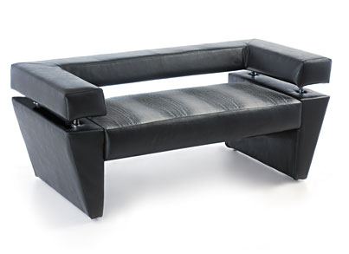 | 1600*830*670 | 12000 | 13600
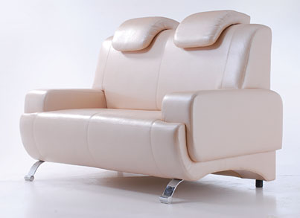 | 1720*950*1180 | 21500 | 24080
 | 1830*770*835
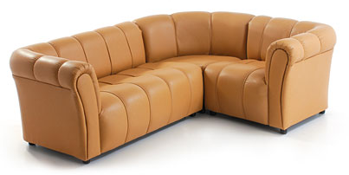 | 600*770*735 | 4800 | 5400
 | 830*770*735 | 6640 | 7470
 | 1060*770*735 | 8480 | 9540
 | 1170*770*735 | 9360 | 10530
 | 1400*770*735 | 11200 | 12600
 | 1630*770*735 | 13040 | 14670
 | 1570*770*735 | 12560 | 14130
 | 1800*770*735 | 14400 | 16200
 | 2030*770*735 | 16240 | 18270
 | 770*770*735

С уважением, “ARTDIVAN”,
сот.271-16-95, т/ф: 240-90-81

